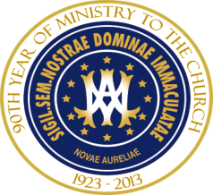
ORIENTATION FOR NEW MA PROGRAM STUDENTS
AUGUST 13, 2016 CLASSROOM 4-5

AGENDA

8:00-9:00 a.m. Morning Prayer Dr. Chris Baglow
Welcome
Registration process Ms. Cindy Garrity
Drop/Add forms
Formal Withdrawal Process
Fees Ms. Michelle Klein
Dining Room

(Orientation divides into two groups: ILEM/MAPL with Dr. Daniella Jerome and Mrs. Susie Veters, MATS with Dr. Chris Baglow)

9:00 a.m.-12:00 noon Overview of MATS Program
Scope and Purpose
Philosophy of MA Program
Degree Tracks
Program of Study/Changes in Degree Tracks
Access to Notre Dame Seminary Campus
Dress Code
Guide to Degree Requirements
Comprehensive Examinations
Language Competency
Research Thesis
Course Cycle
Course Catalog

12:00 noon-1:15 p.m. Lunch - provided by NDS
(Comprehensive Exam Students join all new students.)

1:15-1:30 p.m. Welcome by Rector Fr. Jim Wehner
Welcome by Academic Dean Dr. Tom Neal

1:30-3:00 p.m. Introduction to Academic Research Mr. Tommy Bender

